**Assignment 15.2:**

**Problem Statement 1:**

Write a partial function to add three numbers in which one number is constant and two

numbers can be passed as inputs and define another method which can take the partial

function as input and squares the result.

package PF  
  
/**This class provides a partial function to all two integers and constant  
 * and another method to return square of integer**/  
  
class Partial {  
    
  val constantInt: Int = 12;  //Defining constant integer  
  
  // Method to add two integers and return their sum  
    
  def add(a: Int, b: Int): Int = a + b;  
  
  //Partial function to add two parameters and constant  
  
  object sumInt extends Function2[Int, Int, Int] {  
  
  override def apply(x: Int, y: Int): Int = add(add(x, y), constantInt)  
    
  }  
  
    
  //Method to return square of input parameter  
    
  def squareInt(i: Int): Int = {  
    var retVal: Int = i * i;  
    return retVal;  
  }  
  
}  
  
object MainObj {  
  def main(args: Array[String]) {  
    var PartialClass = new Partial();  
      
    //Testing partial function  
      
    println("Partial function returns : " + PartialClass.sumInt(4, 8));  
      
    println("Square function returns : " + PartialClass.squareInt(PartialClass.sumInt(5, 6)));  
  }  
}

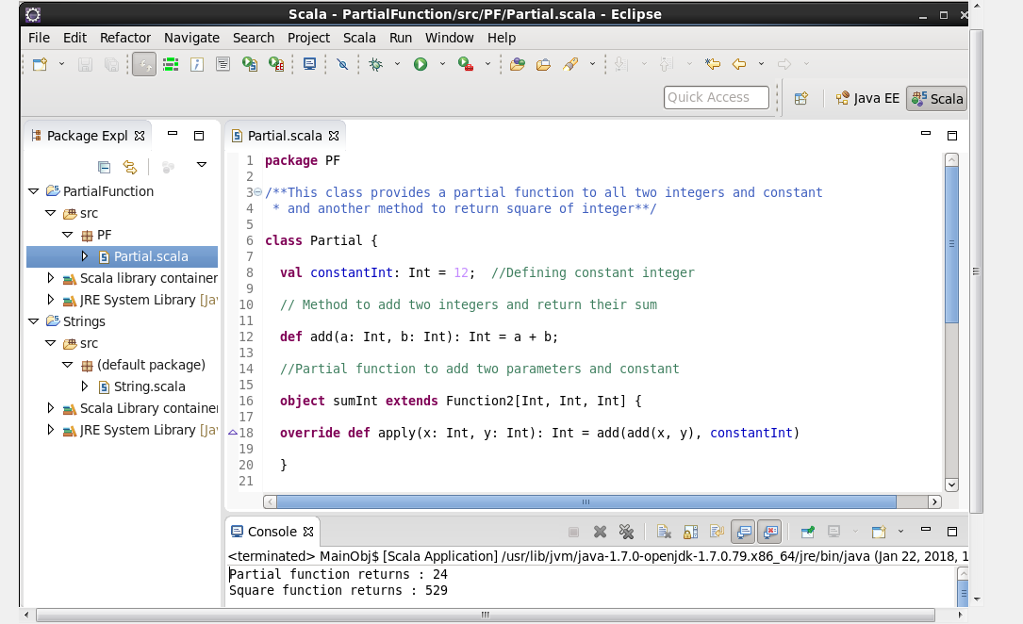

**Output:**

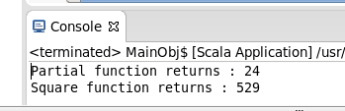

Attached Scala Code:



**Problem Statement 2:**

Write a program to print the prices of 4 courses of Acadgild: Android-12999, Big Data

Development-17999, Big Data Development-17999, Spark-19999 using match and add a

default condition if the user enters any other course.

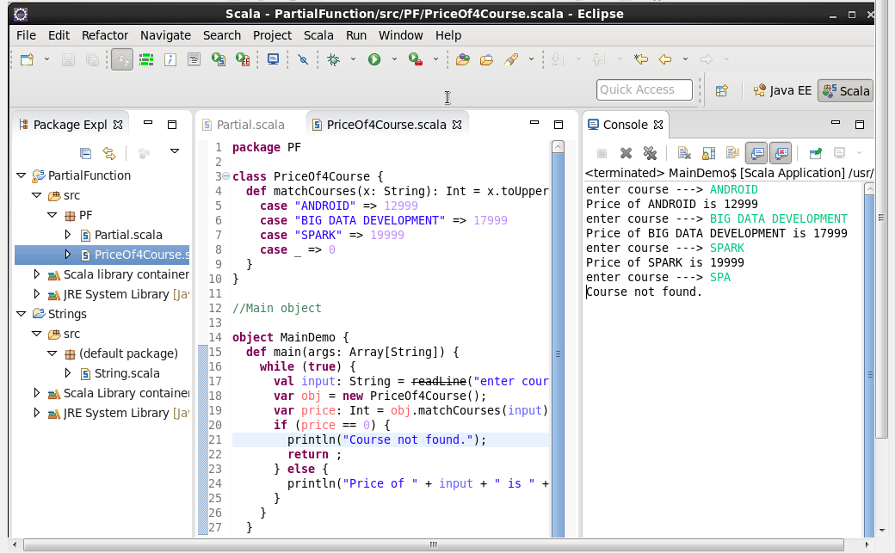

**Output:**

